Practical 1: Selenium IDE Test Suite for Validating Different Web Page Formats

Aim: To install Selenium IDE and create a test suite containing four test cases to validate HTML, XML, JSON, and Dynamic Form web pages.
Steps:
1. Install Selenium IDE extension.
2. Open Selenium IDE and create a new project.
3. Create a test suite named WebFormatValidation.
4. Add four test cases.
5. Execute the suite and verify results.
TEST CASE 1: HTML PAGE VALIDATION
Command | Target | Value
open | https://example.com
assertTitle | Example Domain
verifyText | css=h1 | Example Domain

Test Case 2: XML Response Validation
Command | Target | Value
open | https://www.w3schools.com/xml/note.xml
verifyText | xpath=//to | Tove
verifyText | xpath=//from | Jani

Test Case 3: JSON API Output Validation
Command | Target | Value
open | https://jsonplaceholder.typicode.com/todos/1
verifyText | css=body | userId
verifyText | css=body | title

Test Case 4: Dynamic Form Validation
Command | Target | Value
open | https://www.selenium.dev/selenium/web/web-form.html
type | name=my-text | Sonam
click | css=button
verifyText | css=h1 | Form submitted

Practical 2: Cross-Website Functional Testing Using Selenium IDE
Aim: Perform functional operations such as clicking links, filling forms, selecting dropdown options, and verifying displayed content. Analyze test results and generate execution logs.
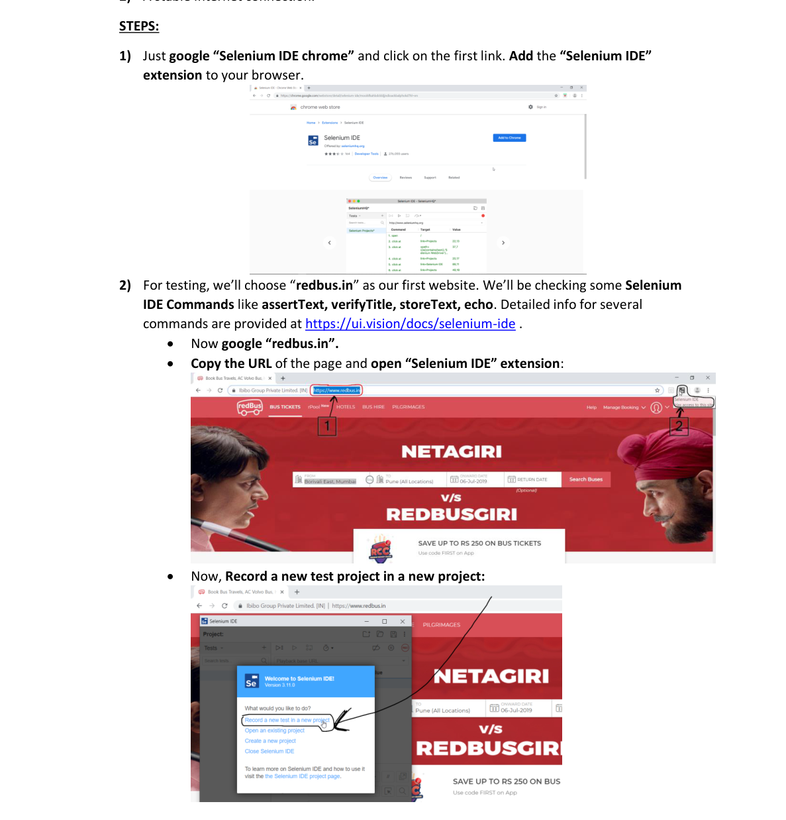

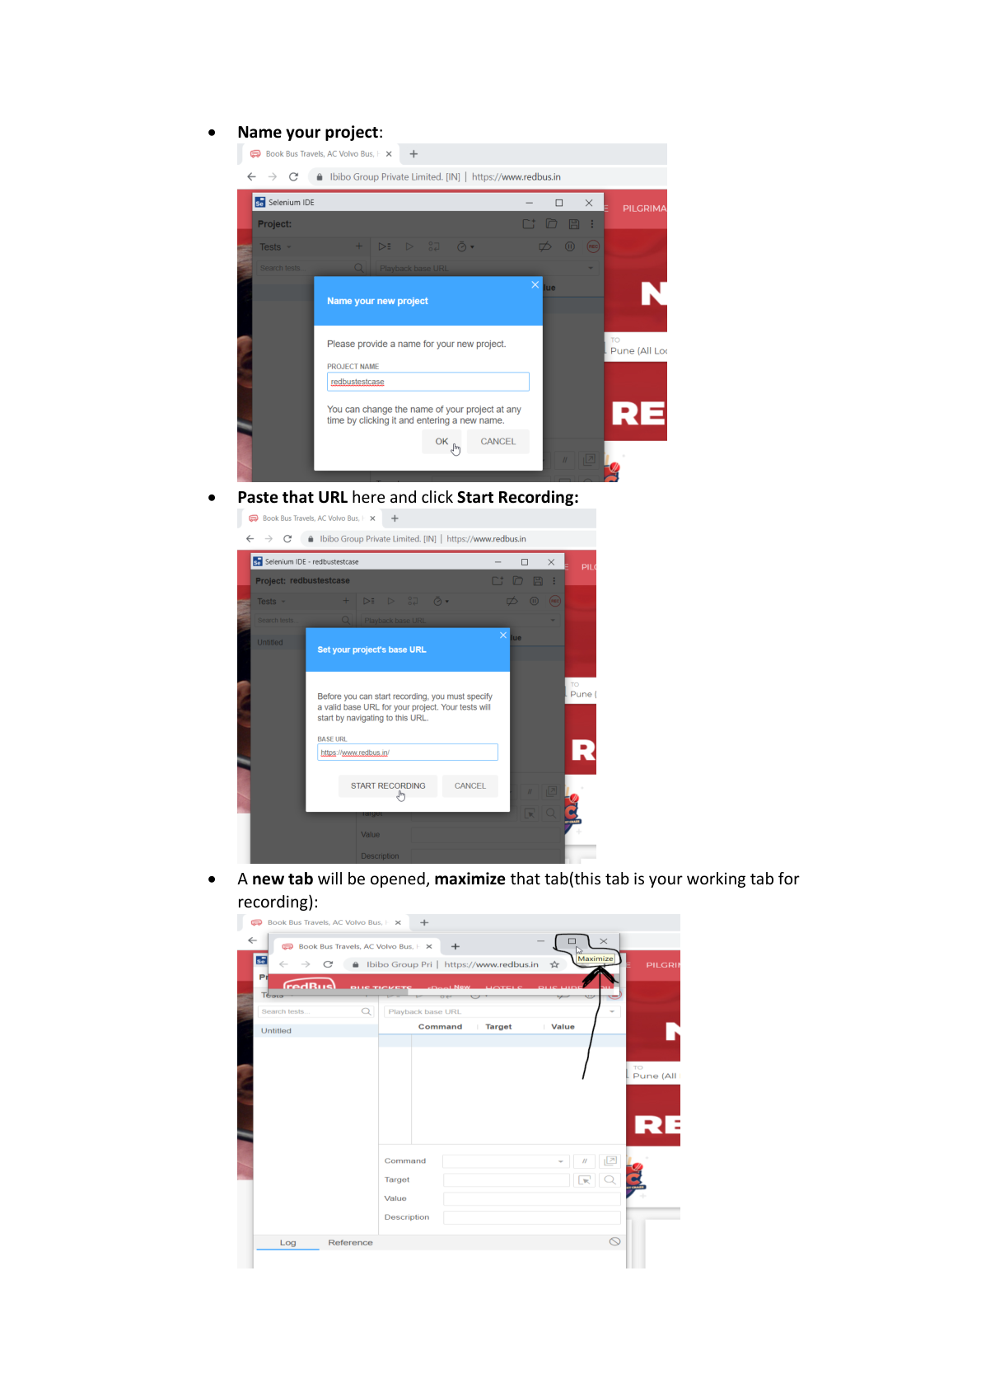

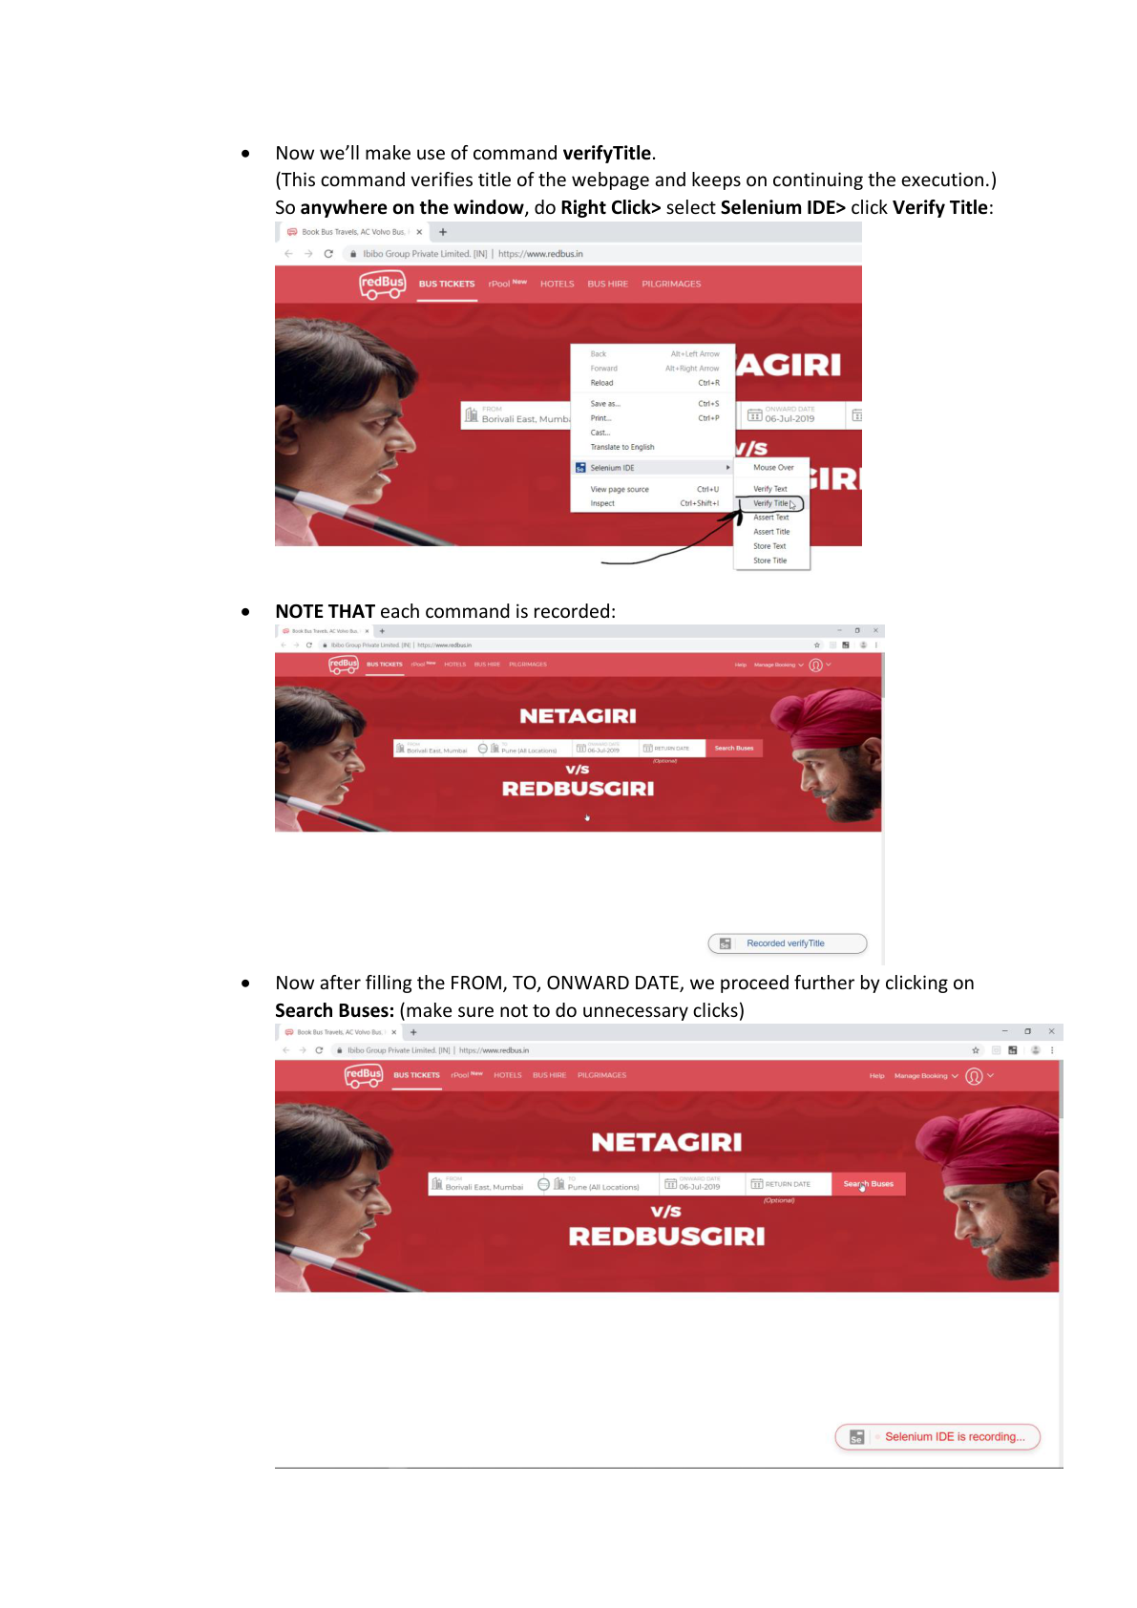

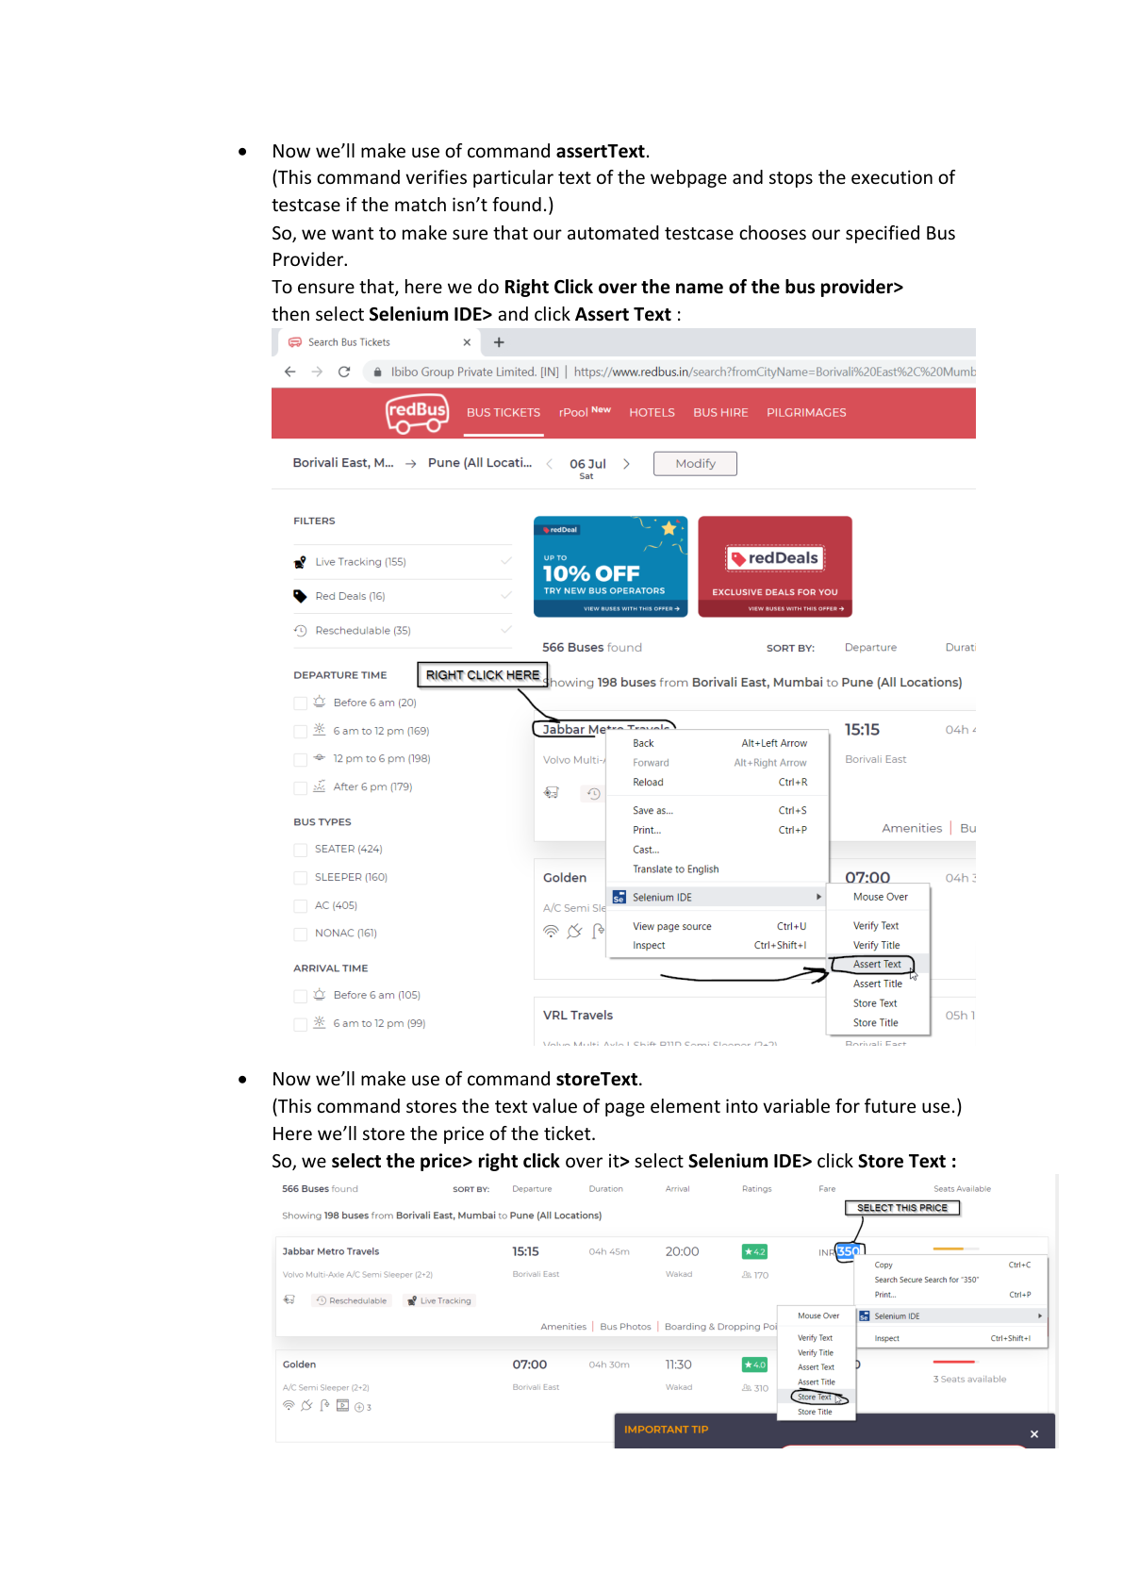

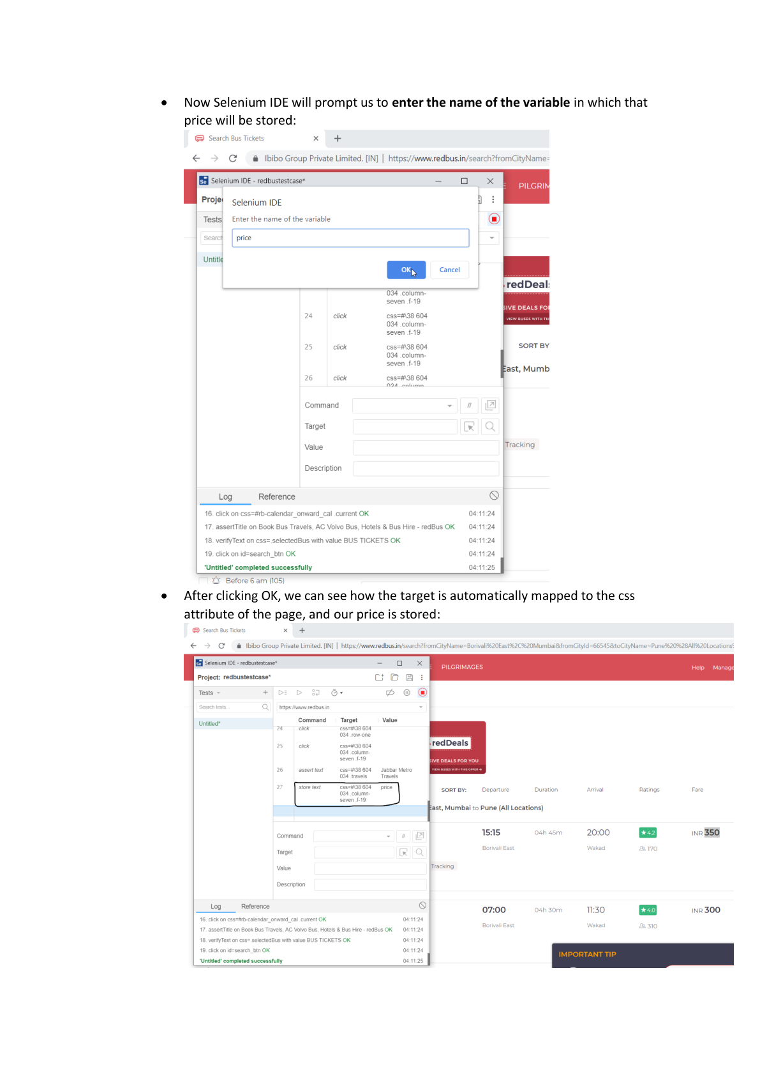

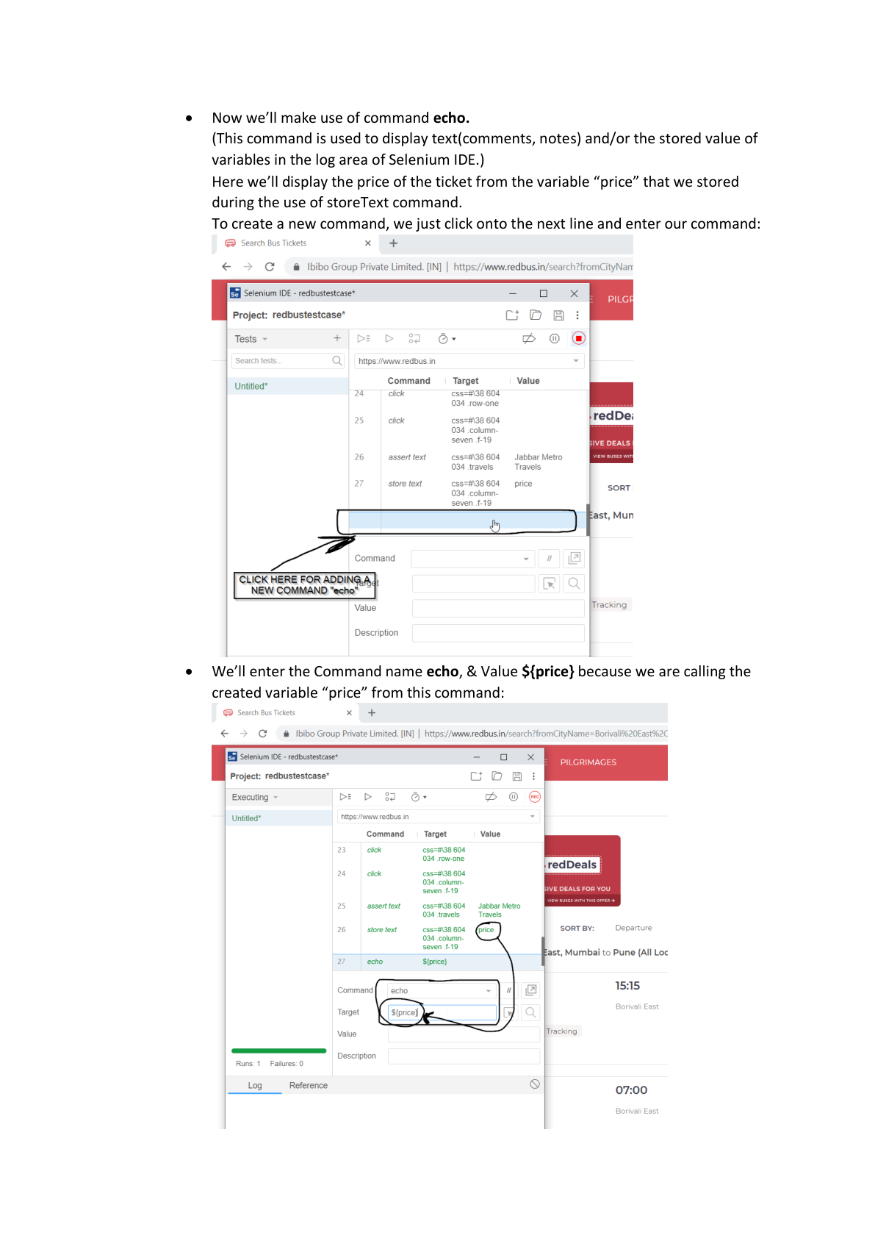

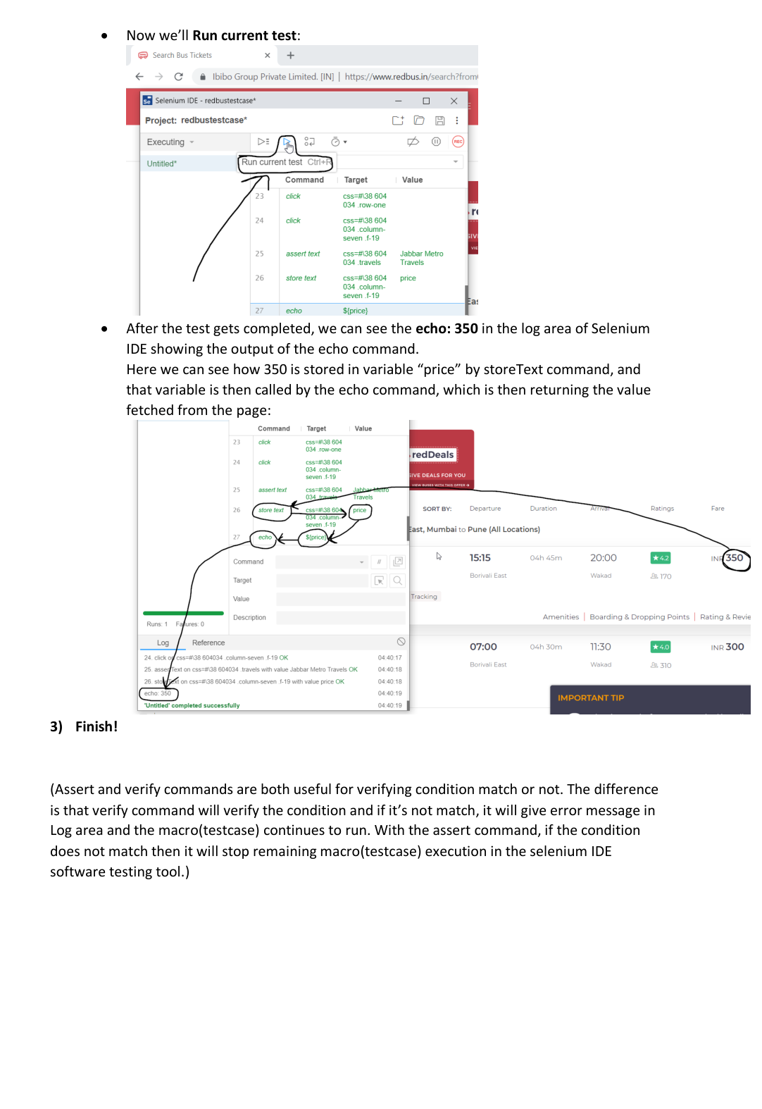

Practical 3: Manual Test Case Design and Execution

Aim:Prepare a Test Plan, Test Scenarios, and Test Cases for a given web application. Execute test cases manually and prepare a Test Execution Report and Defect Report as per STLC process.

1. Test Plan
Item | Details
Project Name | Sample Login Web Application
Testing Type | Manual Testing
Objective | Verify login functionality works correctly
Scope | Login page and validations
Test Environment | Chrome Browser, Windows 11
Tester | Student

2. Test Scenarios
Scenario ID | Test Scenario
TS001 | Valid Login
TS002 | Invalid Login
TS003 | Empty Username
TS004 | Empty Password
TS005 | Password Masking

3. Test Cases
TC ID | Description | Steps | Test Data | Expected Result | Actual Result | Status
TC001 | Valid Login | Enter credentials and login | admin/admin123 | Login success | Login success | Pass
TC002 | Invalid Password | Enter wrong password | admin/12345 | Error message | Error message | Pass
TC003 | Empty Username | Leave username blank | Blank/admin123 | Validation message | Validation message | Pass
TC004 | Empty Password | Leave password blank | admin/Blank | Validation message | Validation message | Pass
TC005 | Password Masking | Enter password | admin123 | Password hidden | Password visible | Fail

4. Test Execution Report
Metric | Value
Total Test Cases | 5
Executed Test Cases | 5
Passed | 4
Failed | 1
Pass Percentage | 80%
Fail Percentage | 20%

5. Defect Report
Defect ID | Summary | Severity | Status
BUG001 | Password field not masked | Medium | Open
Defect Details: Password entered by user is visible instead of hidden.

Practical 4: Selenium Server (Grid) Configuration and Remote Execution
Aim:Selenium Server (Grid) Install and configure Selenium Server in Hub-Node architecture. Execute a test script on multiple browsers using Remote WebDriver and compare cross-browser results.

Step 1: Check Java
Open Command Prompt.
Command: java -version
Verify Java 17 is installed.
Screenshot: Paste your screenshot here.

Step 2: Install JDK 17
Download Windows x64 Installer, install it, and verify Java 17.
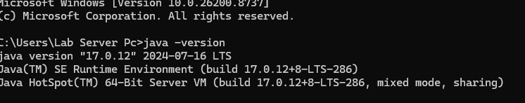

Step 3: Download Selenium Server
Download selenium-server-4.44.0.jar and save it in C:\SeleniumGrid.

Step 4: Open CMD
Command: cd C:\SeleniumGrid
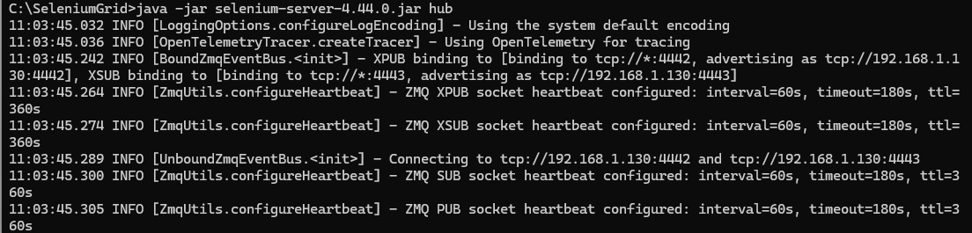

Step 5: Start Selenium Grid open another command prompt
Command: java -jar selenium-server-4.44.0.jar hub
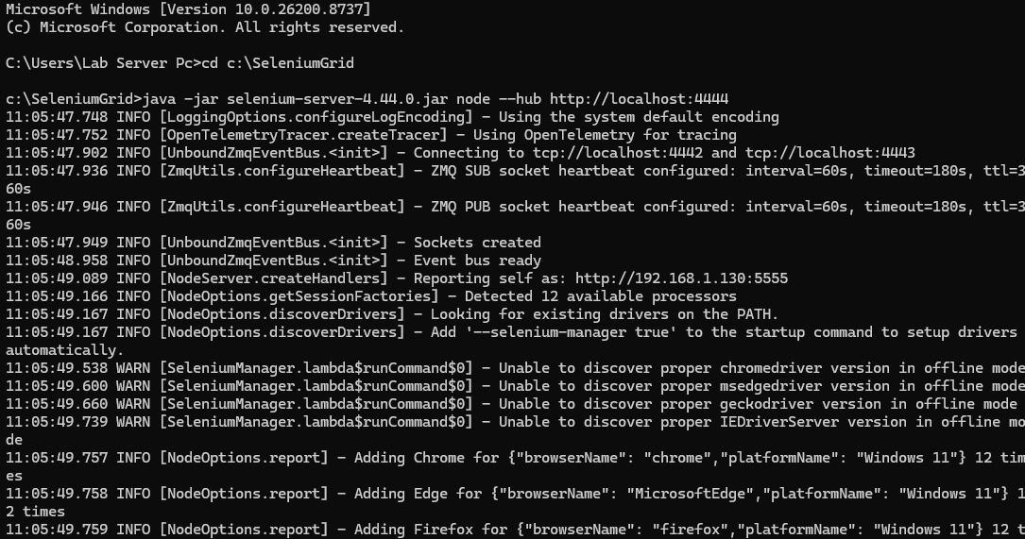

Step 6: Open Dashboard

Step 7: Verify Browsers
Ensure browser icons (Chrome/Edge) are visible.
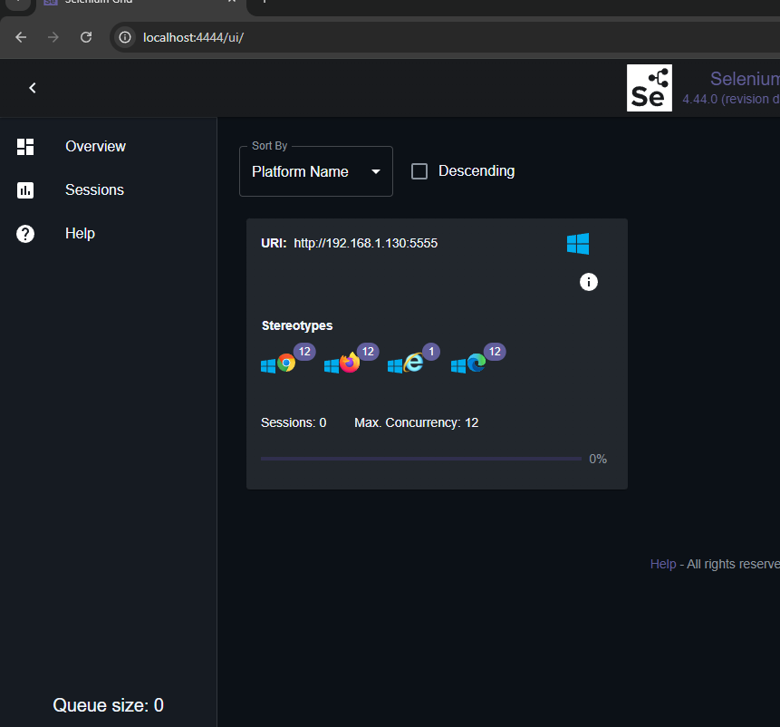

Step 8: Install Eclipse
Install Eclipse IDE for Java Developers.

Step 9: Create Project
Create Java project SeleniumGridDemo.

Step 10: Add Selenium Libraries
Configure Selenium libraries or Maven.
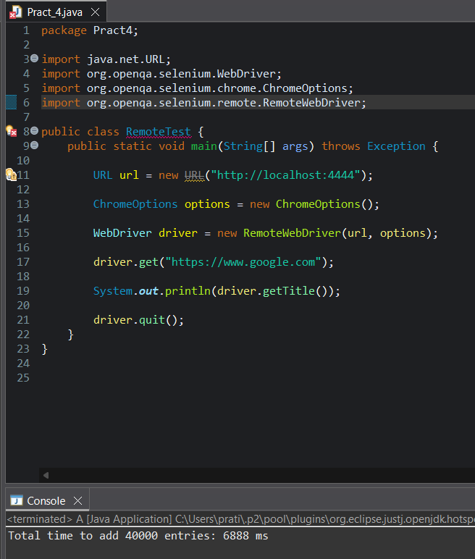
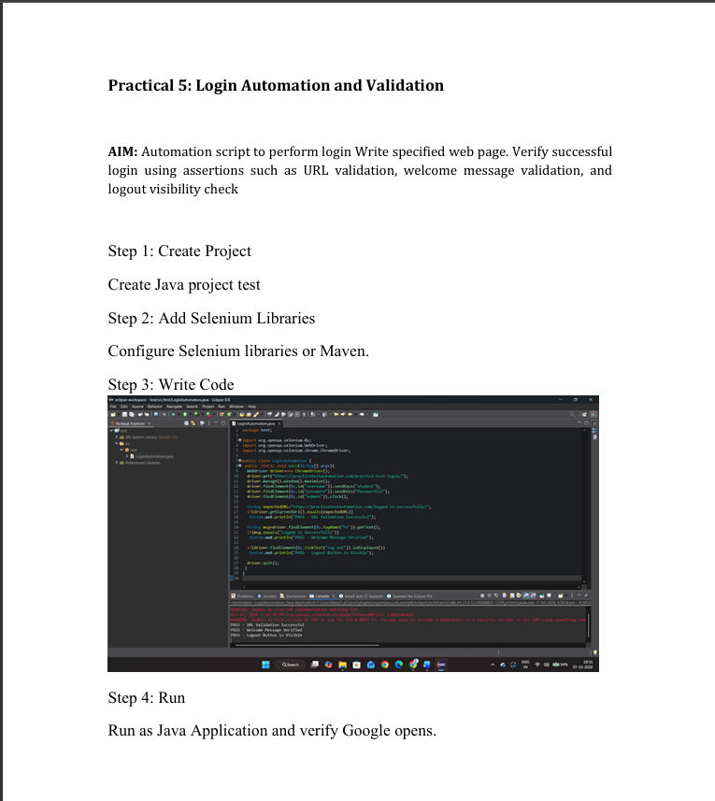
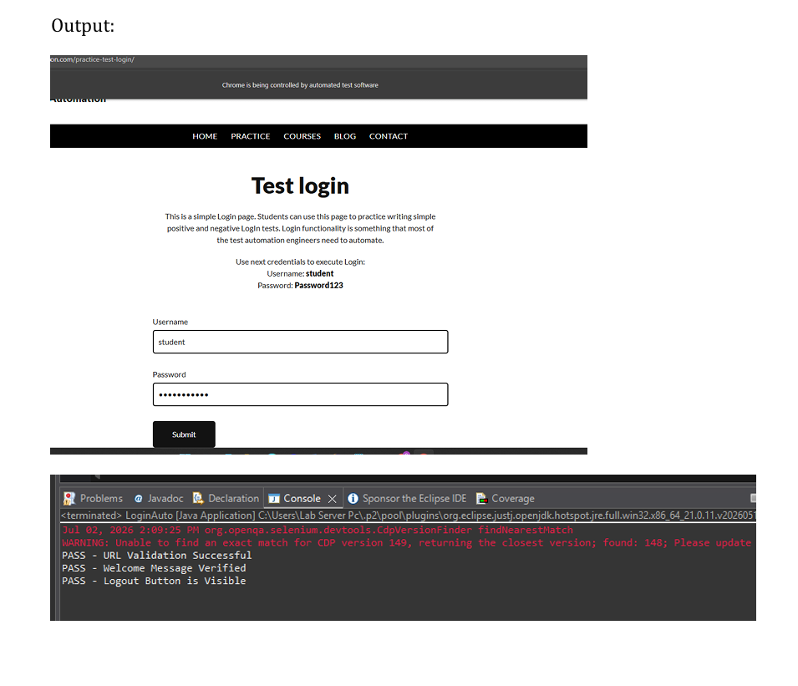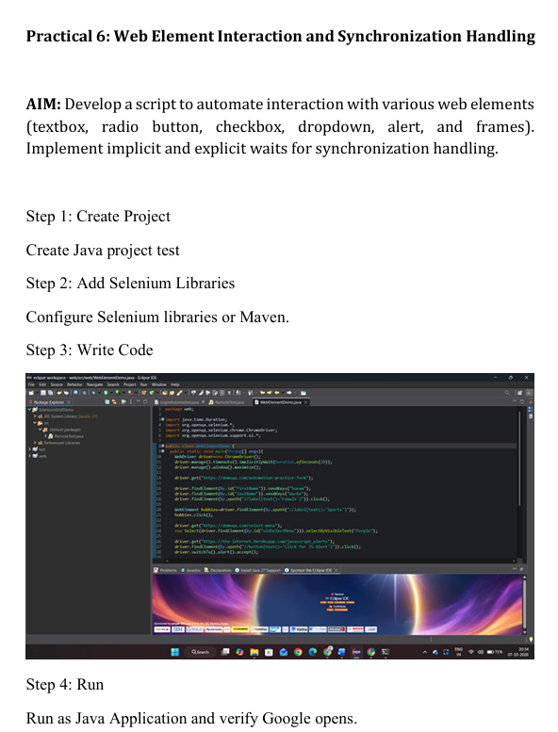

Ourput:
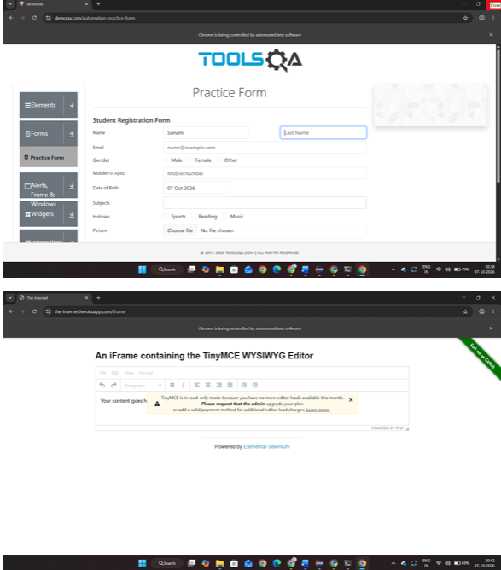

Practical 7: Data-Driven Testing Using Excel Integration
Aim: Write a program to update 10 student records in an Excel file and validate changes on the web application. Perform data reading, writing, and verification using Apache POI library
Step 1: Create Project
Create Java project test
Step 2: Add Selenium Libraries
Configure Selenium libraries or Maven.

Code and output:
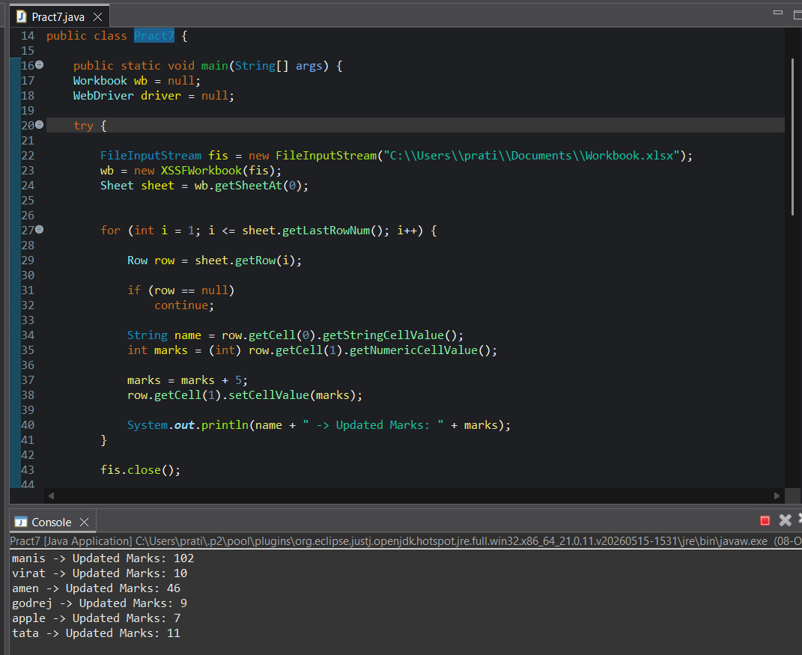

Practical 8: Data Extraction and Score Analysis from Web Table
Aim: Automate extraction of student marks from a dynamic web table and determine the number of students scoring above 60 in at least one subject. Compute total count and percentage.
Step 1: Create Project
Create Java project test
Step 2: Add Selenium Libraries
Configure Selenium libraries or Maven.
Step 3 :write code
Code and output:
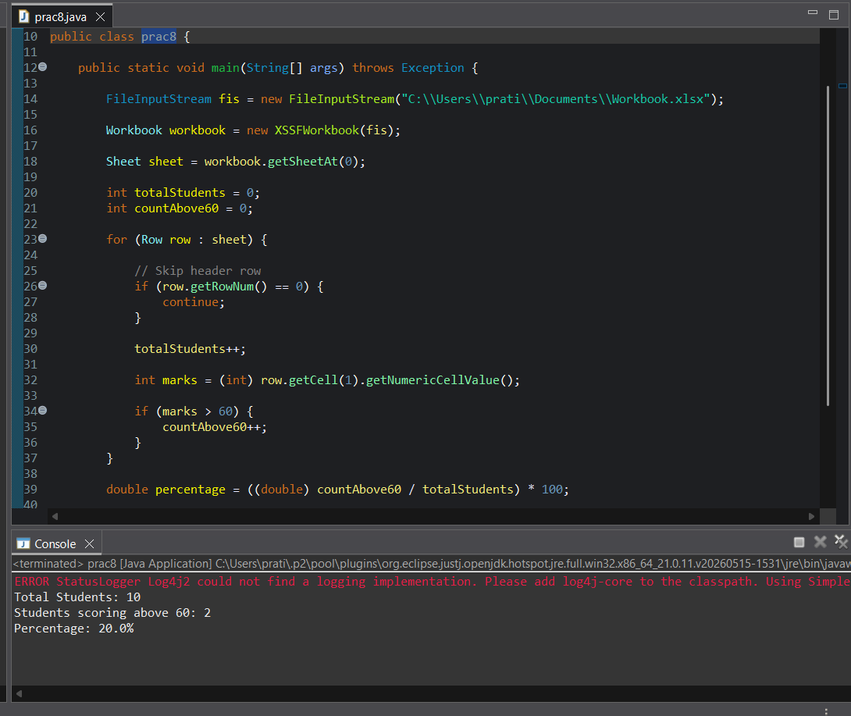

Practical 9: Object Identification and Counting on Web Page
Aim: Write a program to identify and count the total number of objects present on a web page including links, images, buttons, and input elements. Display categorized counts.
Step 1: Create Project
Create Java project test
Step 2: Add Selenium Libraries
Configure Selenium libraries or Maven.
Step 3: Write code:
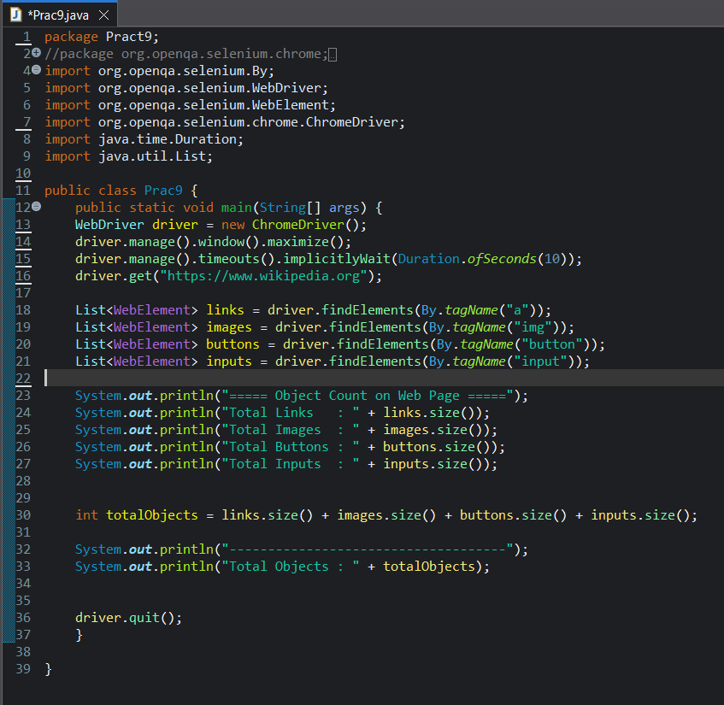

Output: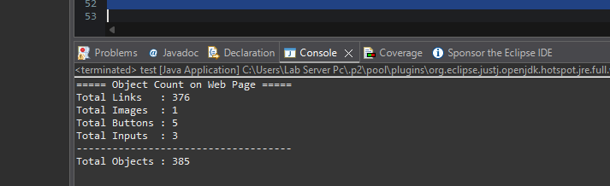

Practical 10: List and Combo Box Item Verification
Aim: Automate the process of identifying a list or dropdown box on a web page and determine the total number of items. Validate default selected value and perform selection testing.
Step 1: Create Project
Create Java project test
Step 2: Add Selenium Libraries
Configure Selenium libraries or Maven.
Step 3: Code
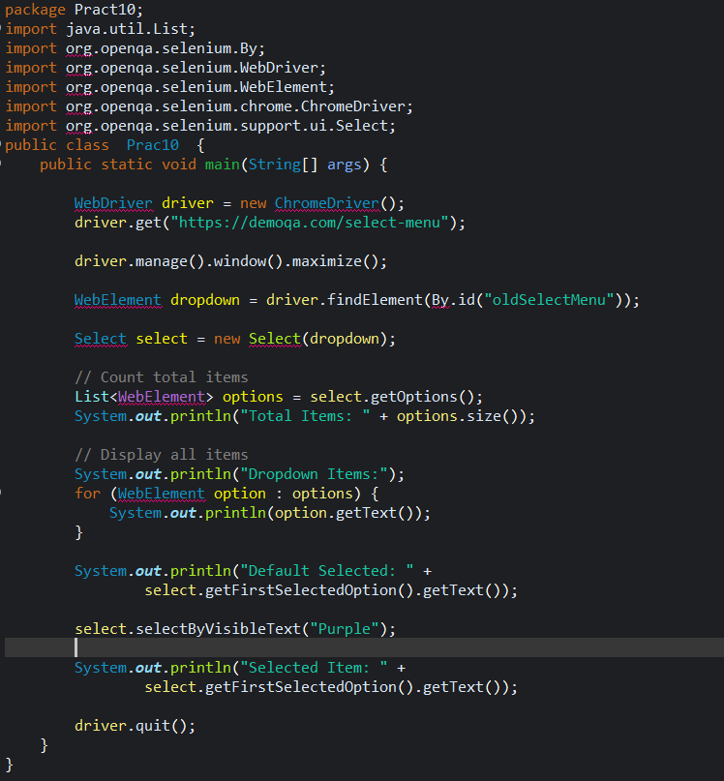
Output:
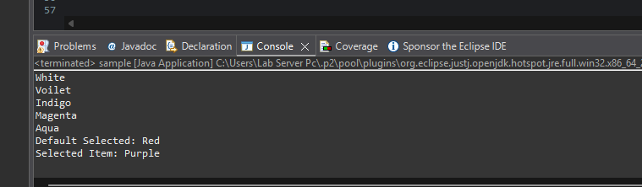

Practical 11: Checkbox Identification and Validation
Aim: Write a program to count the total number of checkboxes on a web page, including checked and unchecked counts. Perform dynamic selection and validation.
Tool: Selenium WebDriver
Step 1: Create Project
Create Java project test
Step 2: Add Selenium Libraries
Configure Selenium libraries or Maven.
Step 3: Write Code
package prc11;

import org.openqa.selenium.By;
import org.openqa.selenium.WebDriver;
import org.openqa.selenium.WebElement;
import org.openqa.selenium.chrome.ChromeDriver;
import java.util.List;

public class CheckboxValidation {

public static void main(String[] args) {

// Selenium 4.6+ automatically manages ChromeDriver
WebDriver driver = new ChromeDriver();

// Open webpage containing checkboxes
driver.get("C:/Users/Lab Server Pc/Documents/checkbox.html");
driver.manage().window().maximize();

// Locate all checkboxes on the page
List<WebElement> checkboxes = driver.findElements(
By.xpath("//input[@type='checkbox']")
);

int totalCheckboxes = checkboxes.size();
int checkedCount = 0;
int uncheckedCount = 0;

// Count checked and unchecked checkboxes
for (WebElement checkbox : checkboxes) {

if (checkbox.isSelected()) {
checkedCount++;
} else {
uncheckedCount++;
}
}
System.out.println("Total Checkboxes: " + totalCheckboxes);
System.out.println("Checked Checkboxes: " + checkedCount);
System.out.println("Unchecked Checkboxes: " + uncheckedCount);
// Dynamically select unchecked checkboxes
for (WebElement checkbox : checkboxes) {

if (!checkbox.isSelected()) {
checkbox.click();
}
}
// Validate checkbox selection after clicking
int selectedAfterClick = 0;

for (WebElement checkbox : checkboxes) {

if (checkbox.isSelected()) {
selectedAfterClick++;
}
}
System.out.println("Checkboxes selected after dynamic selection: "
+ selectedAfterClick);
// Validation result
if (selectedAfterClick == totalCheckboxes) {
System.out.println("Validation Passed: All checkboxes are selected.");
} else {
System.out.println("Validation Failed: Some checkboxes are not selected.");
}
// Close browser
driver.quit();
}
}

Checkbox.html
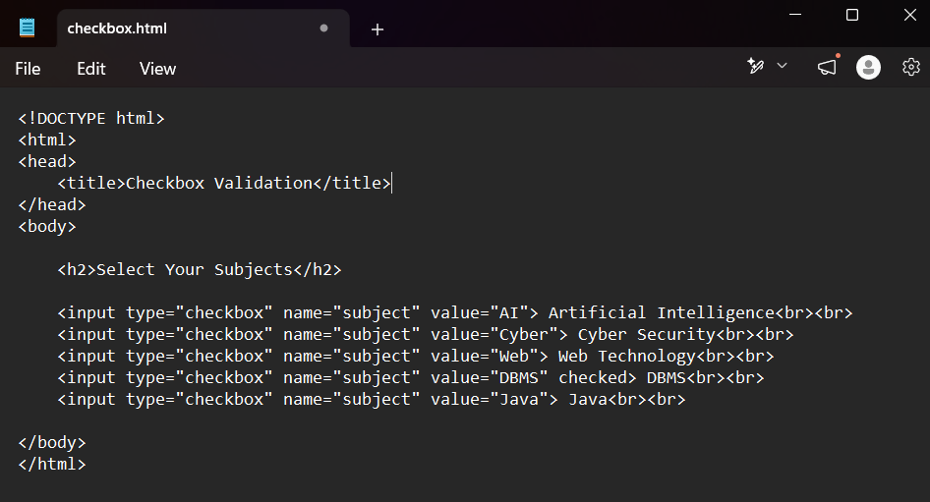

Step 4: Add path of checkbox.html file in code
Step 5: Run
Run as Java Application and verify Google opens.
OUTPUT:
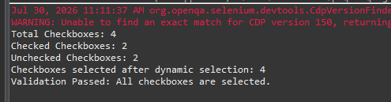

Practical 12: Dynamic Web Table Handling and Sorting Validation
Aim: Automate extraction of data from a dynamic web table. Validate sorting functionality and verify correctness of filtered results.
Step 1: Create Project
Create Java project test
Step 2: Add Selenium Libraries
Configure Selenium libraries or Maven.
Step 3: Write Code
package prc12;
import org.openqa.selenium.By;
import org.openqa.selenium.WebDriver;
import org.openqa.selenium.WebElement;
import org.openqa.selenium.chrome.ChromeDriver;

import java.util.ArrayList;
import java.util.Collections;
import java.util.List;

public class DynamicTableValidation {
public static void main(String[] args) {

WebDriver driver = new ChromeDriver();

// Open local HTML file
driver.get("C:/Users/Lab Server Pc/Documents/dynamic_table.html");

driver.manage().window().maximize();

// Locate table rows dynamically
List<WebElement> rows = driver.findElements(
By.xpath("//table[@id='employeeTable']//tr")
);

System.out.println("Total Rows: " + (rows.size()-1));

// Extract table data
System.out.println("Employee Details:");

for(int i=1; i<rows.size(); i++) {

List<WebElement> columns =
rows.get(i).findElements(By.tagName("td"));

System.out.println(
columns.get(0).getText() + " "
+ columns.get(1).getText() + " "
+ columns.get(2).getText()
);
}

// Store original names
List<String> actualNames = new ArrayList<>();

for(int i=1; i<rows.size(); i++) {

String name = rows.get(i)
.findElements(By.tagName("td"))
.get(1)
.getText();

actualNames.add(name);
}

// Click column header to sort
driver.findElement(
By.xpath("//th[contains(text(),'Name')]")
).click();

// Get sorted names
List<WebElement> sortedRows =
driver.findElements(
By.xpath("//table[@id='employeeTable']//tr")
);

List<String> sortedNames = new ArrayList<>();

for(int i=1; i<sortedRows.size(); i++) {

String name = sortedRows.get(i)
.findElements(By.tagName("td"))
.get(1)
.getText();

sortedNames.add(name);
}

// Validate sorting
List<String> expectedNames =
new ArrayList<>(actualNames);

Collections.sort(expectedNames);

if(expectedNames.equals(sortedNames)) {

System.out.println(
"Sorting Validation Passed"
);

} else {

System.out.println(
"Sorting Validation Failed"
);
}

// Filter validation

WebElement search =
driver.findElement(By.id("search"));

search.sendKeys("Alice");

driver.findElement(
By.xpath("//button[text()='Filter']")
).click();

List<WebElement> filteredRows =
driver.findElements(
By.xpath("//table[@id='employeeTable']//tr")
);

boolean resultFound = false;

for(int i=1; i<filteredRows.size(); i++) {

if(filteredRows.get(i).isDisplayed()) {

String name =
filteredRows.get(i)
.findElements(By.tagName("td"))
.get(1)
.getText();

if(name.equals("Alice")) {
resultFound = true;
}
}
}

if(resultFound) {

System.out.println(
"Filter Validation Passed"
);

} else {

System.out.println(
"Filter Validation Failed"
);
}

driver.quit();
}
}

DYNAMIC_TABLE.html
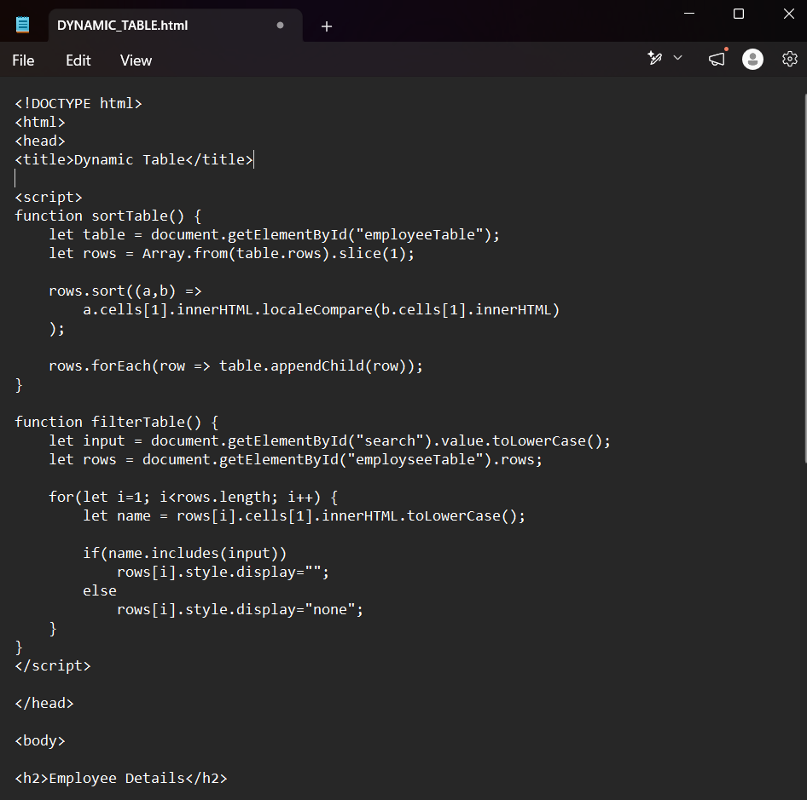

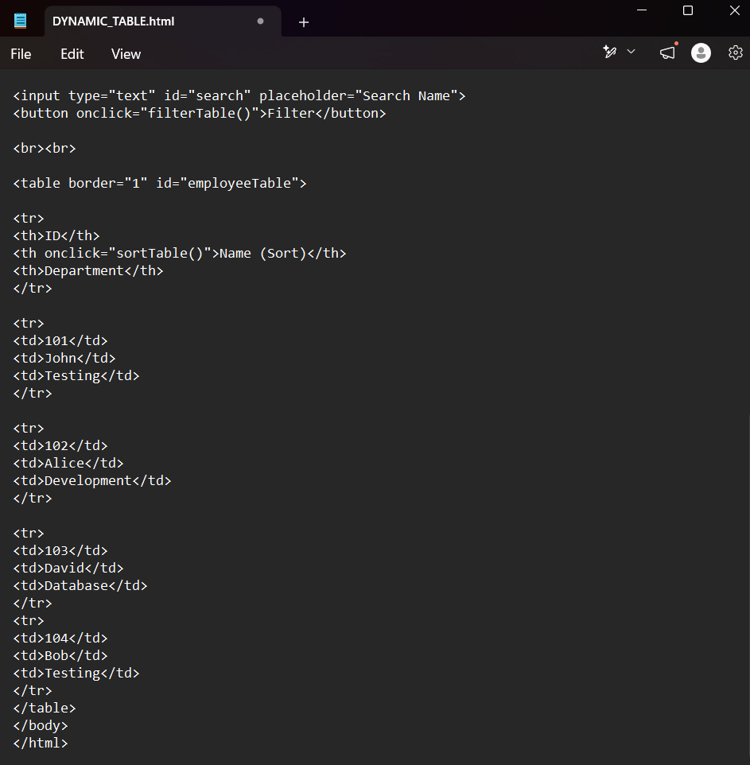
Step 4: Add path of DYNAMIC_TABLE.html file in code
Step 5: Run
Run as Java Application and verify Google opens.
OUTPUT:
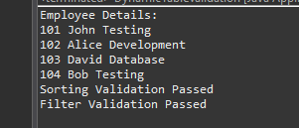

Practical 13: File Upload and Download Automation
Aim: Develop a script to automate file upload and download functionality. Validate successful upload and verify file existence after download.
Step 1: Create Project
Create Java project test
Step 2: Add Selenium Libraries
Configure Selenium libraries or Maven.
Step 3: Write Code
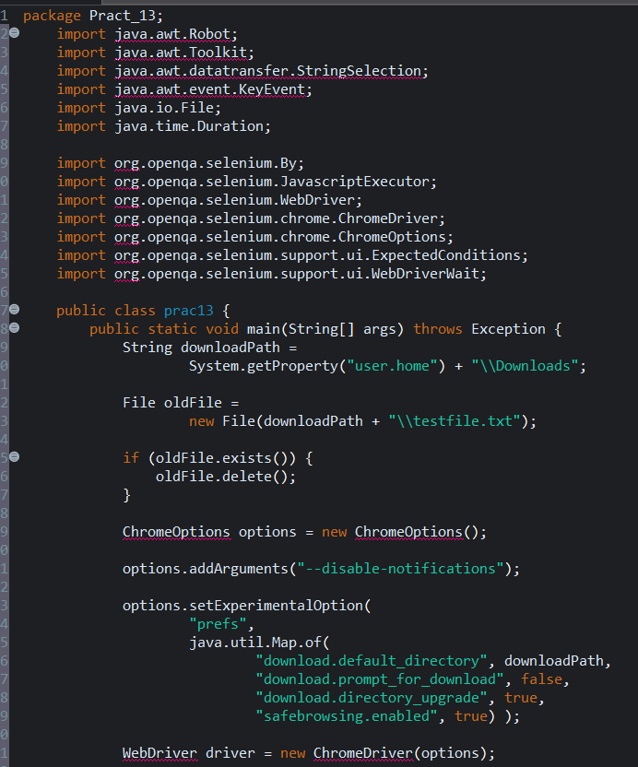
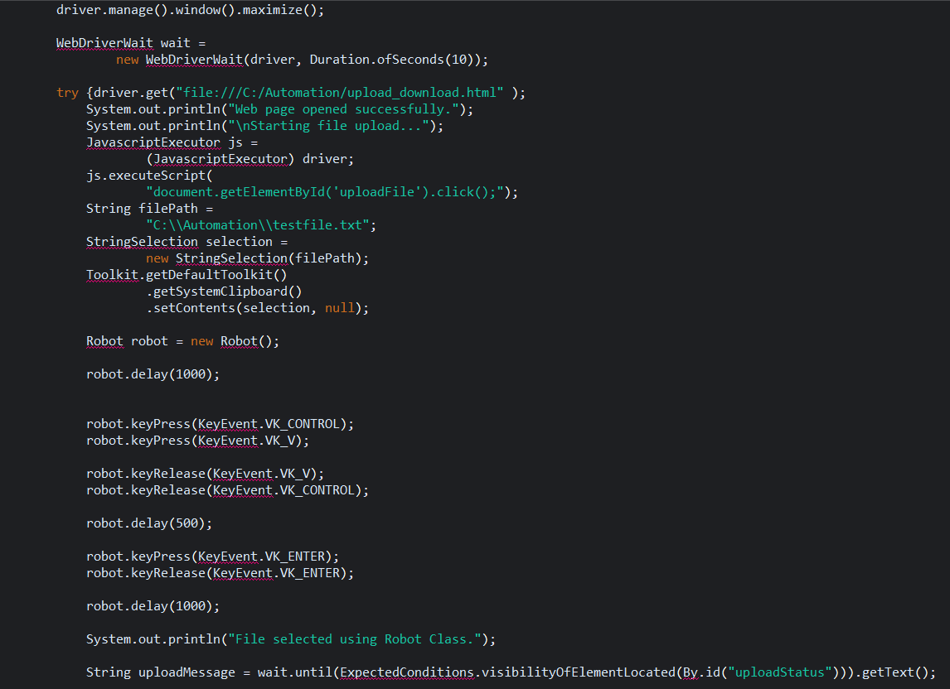
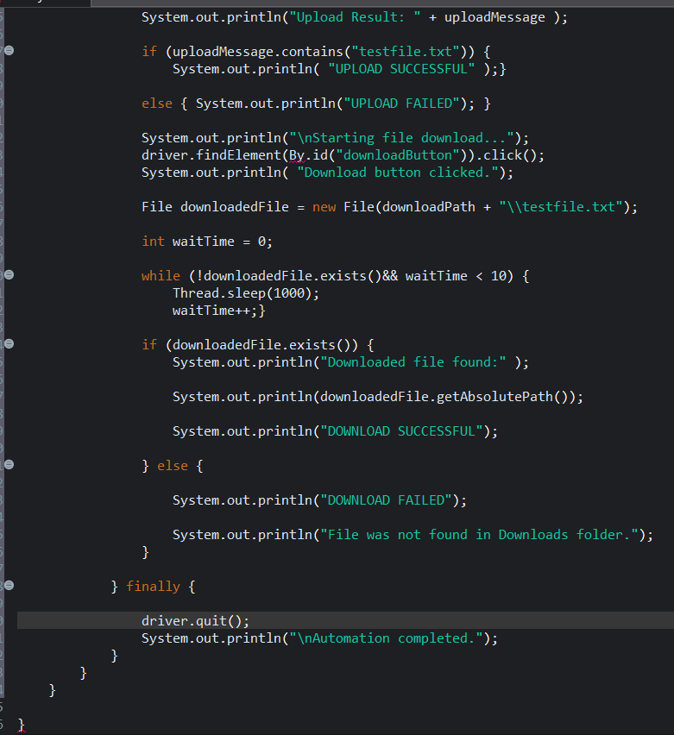

Step 4: Create new folder in c: Automationtestfile.txt
(In testfile.txt just write tour full name.
Also create one html file upload_download.html )
Step 5: write code:
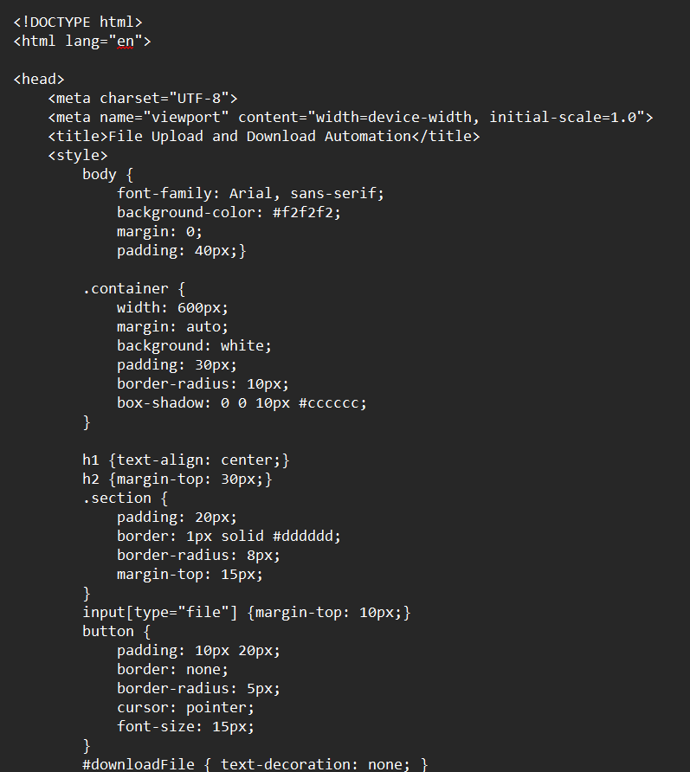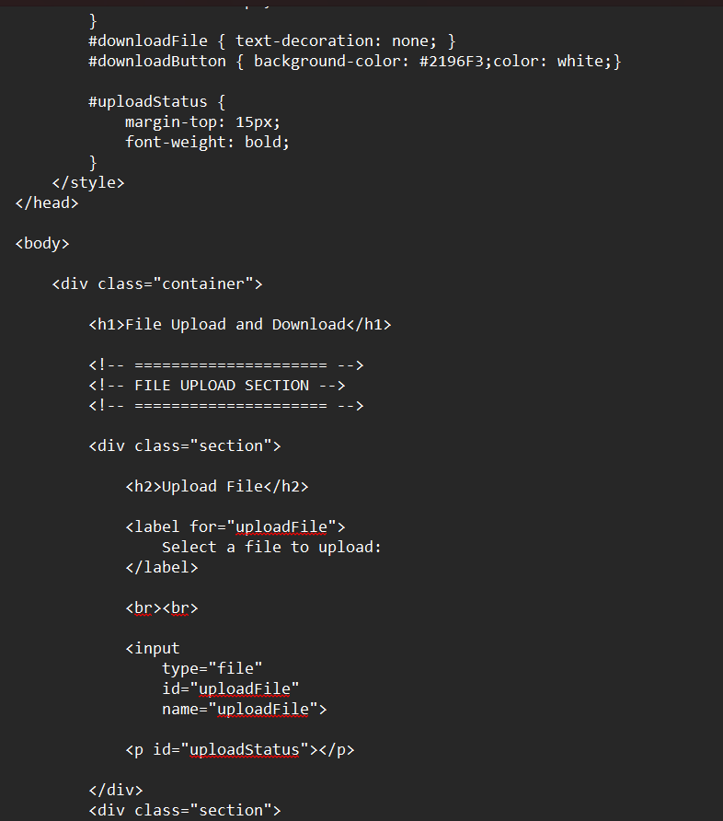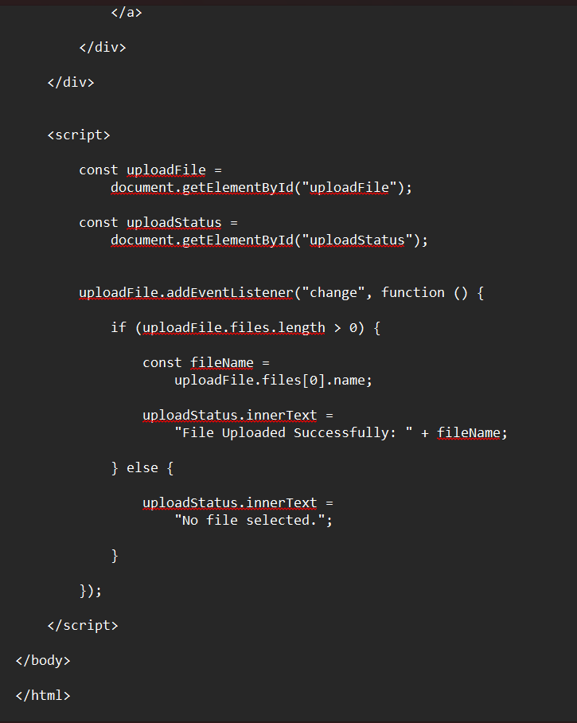

Output:
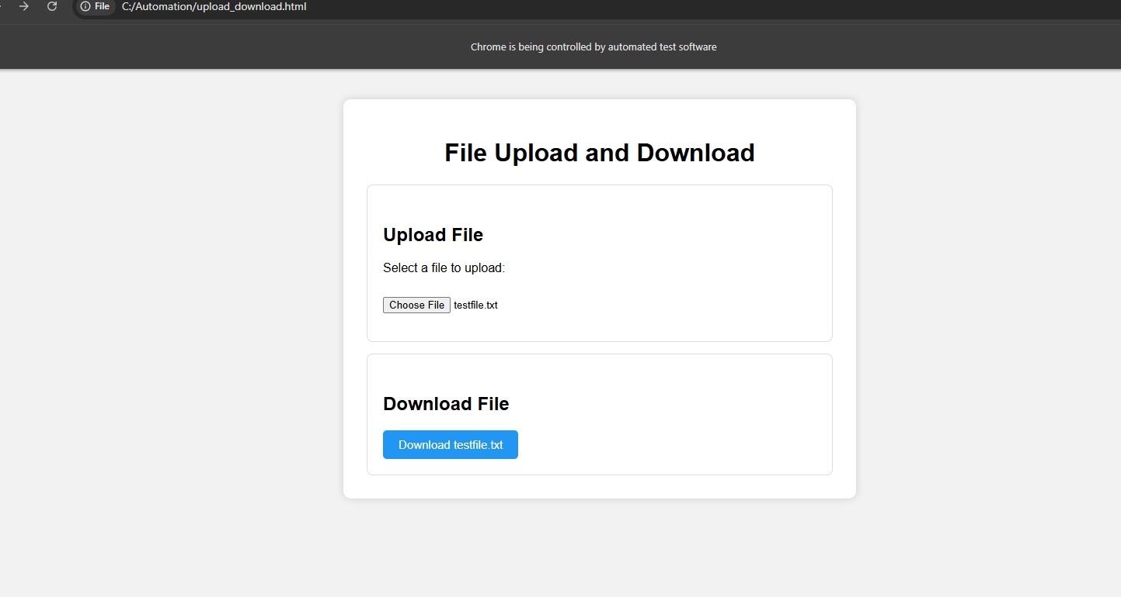
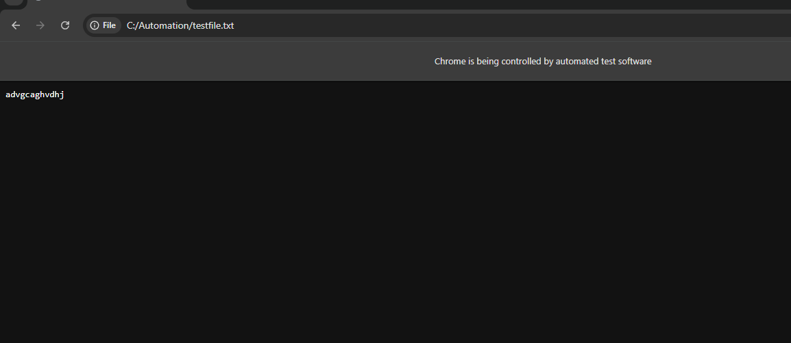

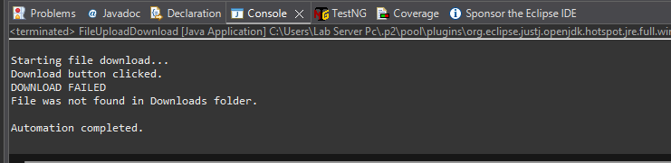

Practical 15: Page Object Model (POM) Framework Implementation
Aim: Design and implement automation framework using Page Object Model (POM). Create reusable page classes and execute modular test cases.
Step 1: Create Project
Create Java project test
Step 2: Add Selenium Libraries
Configure Selenium libraries or Maven.
Step 3:
Install TestNG in Eclipse
1. Go to Help → Eclipse Marketplace.
2. Search for TestNG.
3. Install TestNG for Eclipse.
4. Restart Eclipse when asked.
5. After restarting, right-click a test class and verify that Run As → TestNG Test is available.
5. Create Packages
Right-click src → New → Package. Create these four packages:
Base, pages, tests, utils

Step 4: Write Code:
create DriverManager
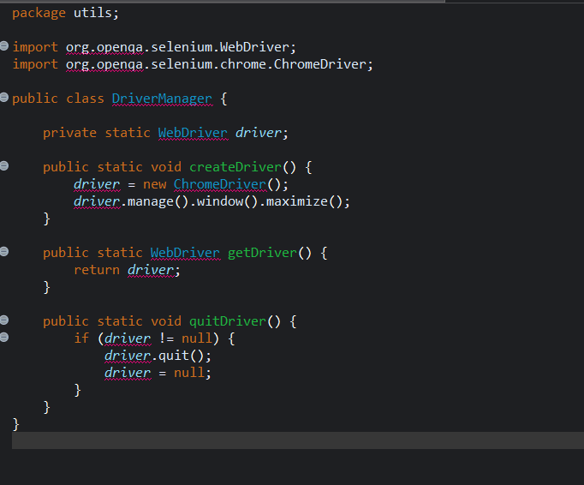
Create bases
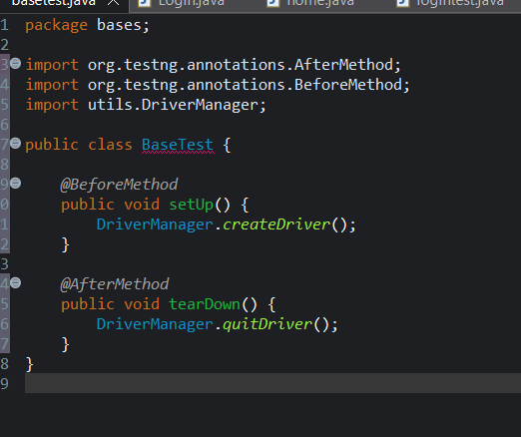
create pages
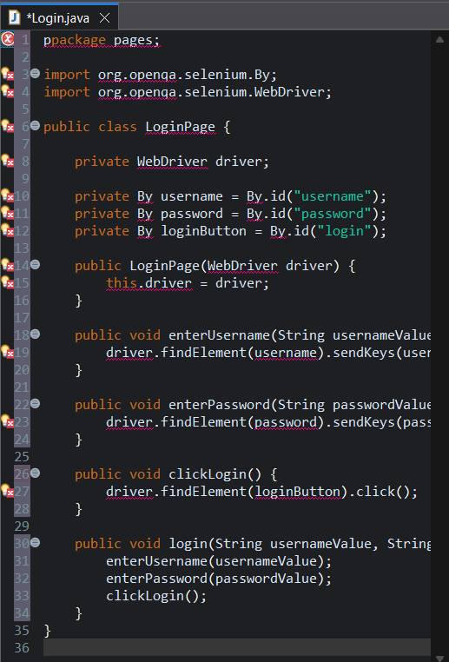
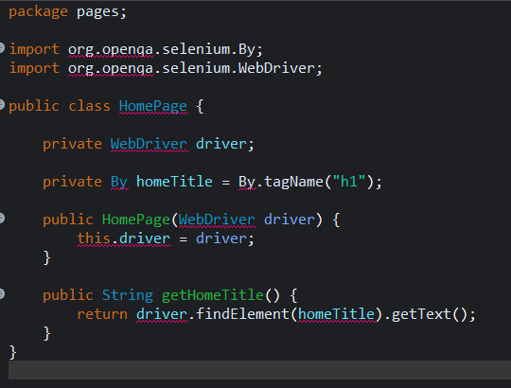
Create Login Test
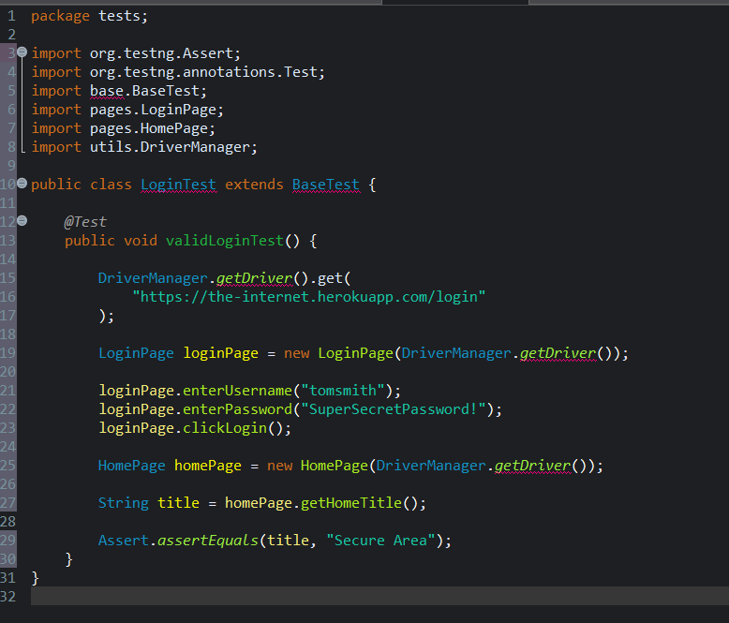
Simple TestNG
TestNG is a testing framework for Java. It is used to create, organize, and run automated tests.
Right-click demo → Build Path → Configure Build Path → Libraries → Classpath → Add External JARs..

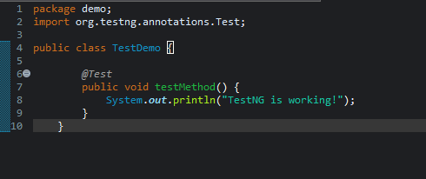@

Output
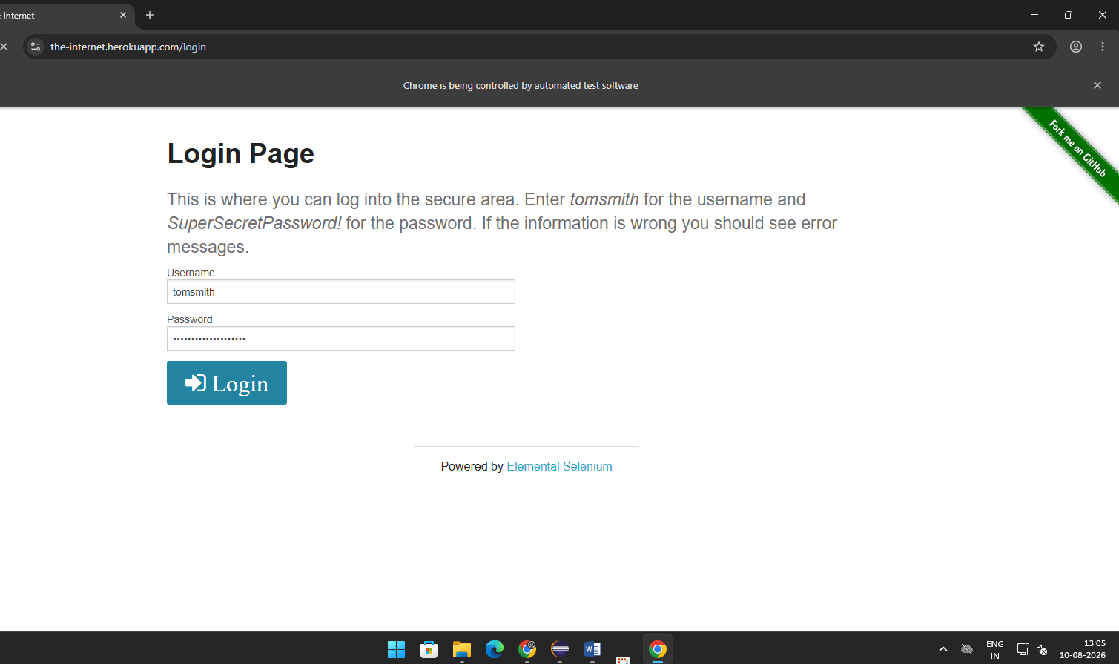
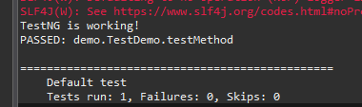

Practical 16: TestNG Framework Implementation and Reporting
Aim: Create and execute automated test cases using TestNG annotations. Group test cases, define priorities, and generate HTML test reports.
Step 1: Create Project
Create Java project test
Step 2: Add Selenium Libraries
Configure Selenium libraries or Maven.
Step 3: Write Code
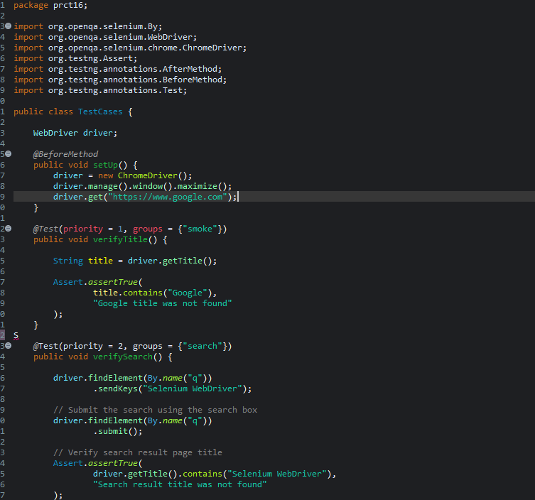
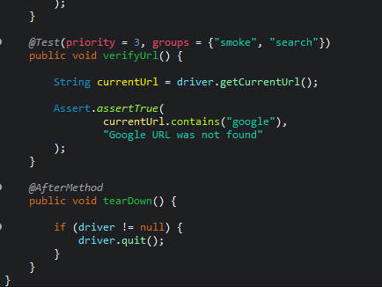

Testing.xml
<?xml version="1.0" encoding="UTF-8"?>

<!DOCTYPE suite SYSTEM "https://testng.org/testng-1.0.dtd">

<suite name="Selenium Test Suite">

<test name="Automation Tests">

<groups>
<run>
<include name="smoke"/>
<include name="search"/>
</run>
</groups>

<classes>
<class name="prct16.TestCases"/>
</classes>

</test>

</suite>

Output:
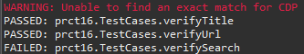

Practical 17: Continuous Integration using Jenkins
Aim: Configure Jenkins to execute Selenium automation scripts automatically. Generate build reports and analyze test execution history.
Step 1: Create Project
Create Java project test
Step 2: Add Selenium Libraries
Configure Selenium libraries or Maven.
Step 3: Write Code
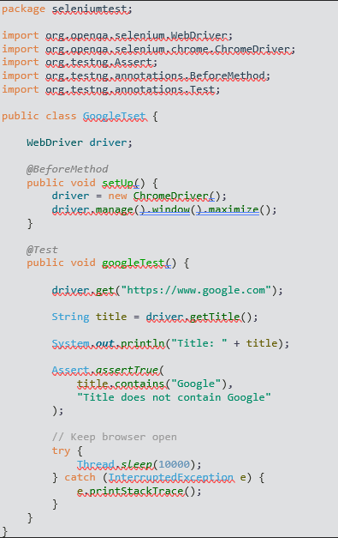

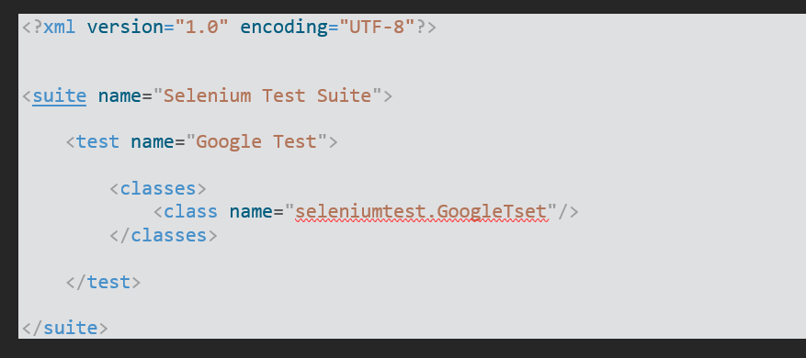
Output:
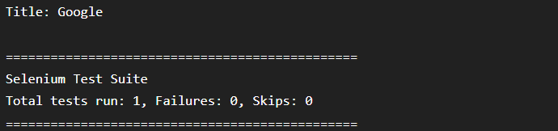

Practical 18: Load Testing Using Apache JMeter

Aim: Design and execute load testing scenarios for a web application. Configure thread groups, ramp-up time, and loop count. Analyze response time, throughput, and error percentage using graphical reports.
1Open the official Apache JMeter download page.
- Download the Windows binary ZIP file, for example: apache-jmeter-5.6.3.zip.
- Extract the ZIP file to a convenient location such as C:\JMeter.
- Open the extracted folder and then open the bin folder.
- Start JMeter using jmeter.bat or jmeterw.cmd.

5. Start Apache JMeter
From Command Prompt, you can start the JMeter GUI with:
cd C:\JMeter\apache-jmeter-5.6.3\bin
jmeter.bat
Replace the path with the actual folder where JMeter was extracted.

6. Create a New Test Plan
- Open Apache JMeter.
- The Test Plan appears in the left panel.
- Right-click Test Plan.
- Select Add → Threads (Users) → Thread Group.

7. Configure Thread Group
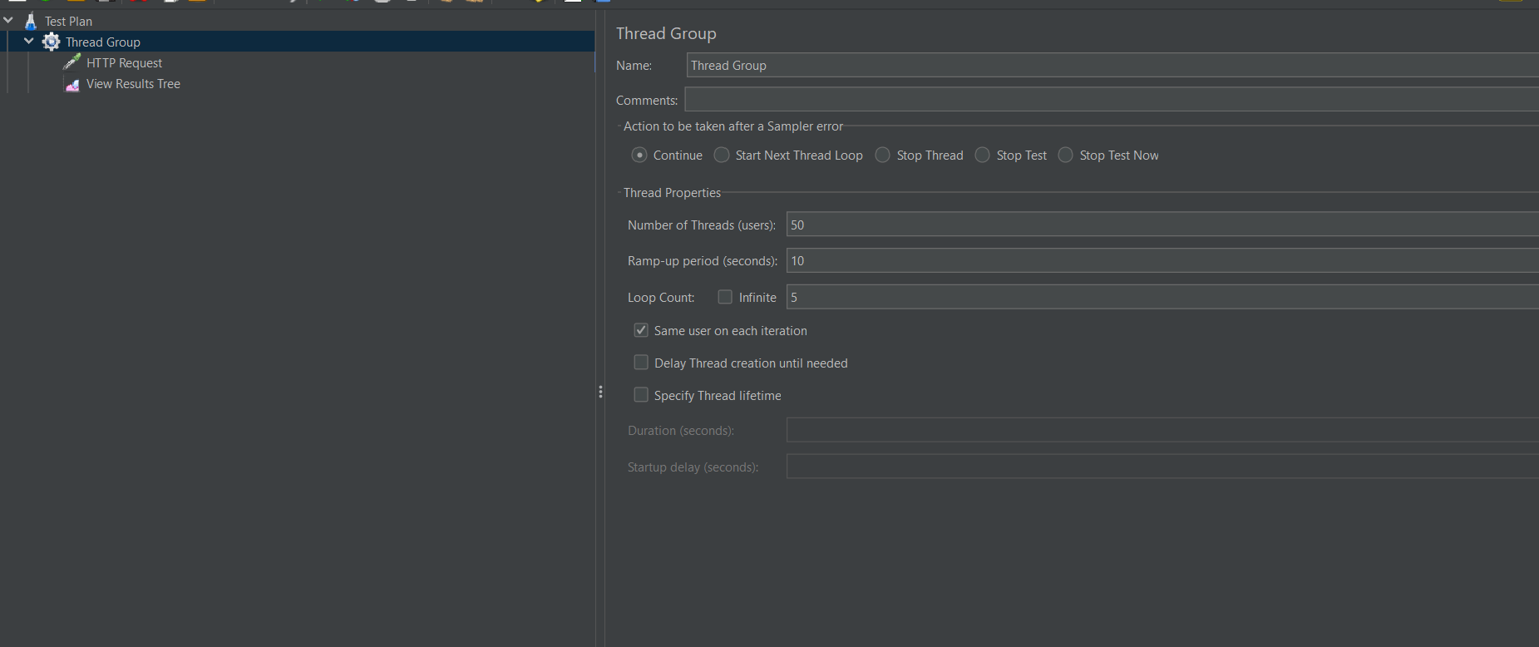

8. Add HTTP Request Sampler
- Right-click Thread Group.
- Select Add → Sampler → HTTP Request.
- Enter the protocol, server name and path of the application.

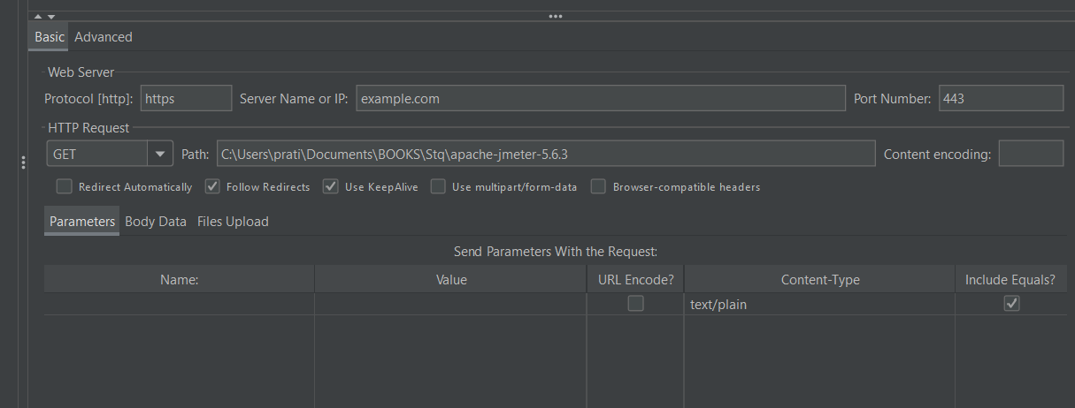9. Add Listeners / Reports
For a basic practical, add the following listeners:
- Summary Report
- Aggregate Report
- Graph Results
- Response Time Percentiles
To add a listener: Right-click Thread Group → Add → Listener → select the required listener.
View Results Tree can be used while debugging a small test, but it should generally be avoided during larger load tests because it consumes memory.

10. Save the Test Plan
- Select File → Save Test Plan As.
- Save the file with a name such as:
LoadTesting.jmx

11. Execute the Load Test
- Click the Start (green triangle) button.
- JMeter starts 50 virtual users gradually over 10 seconds.
- Each user executes the HTTP request 5 times.
- The test therefore generates approximately 250 requests, assuming one sampler and no interruptions.
- After the test completes, open Aggregate Report or Summary Report.

Result :
